Title:Use Case Diagram and Workbreakdown structure

1)

Use Case Diagram:

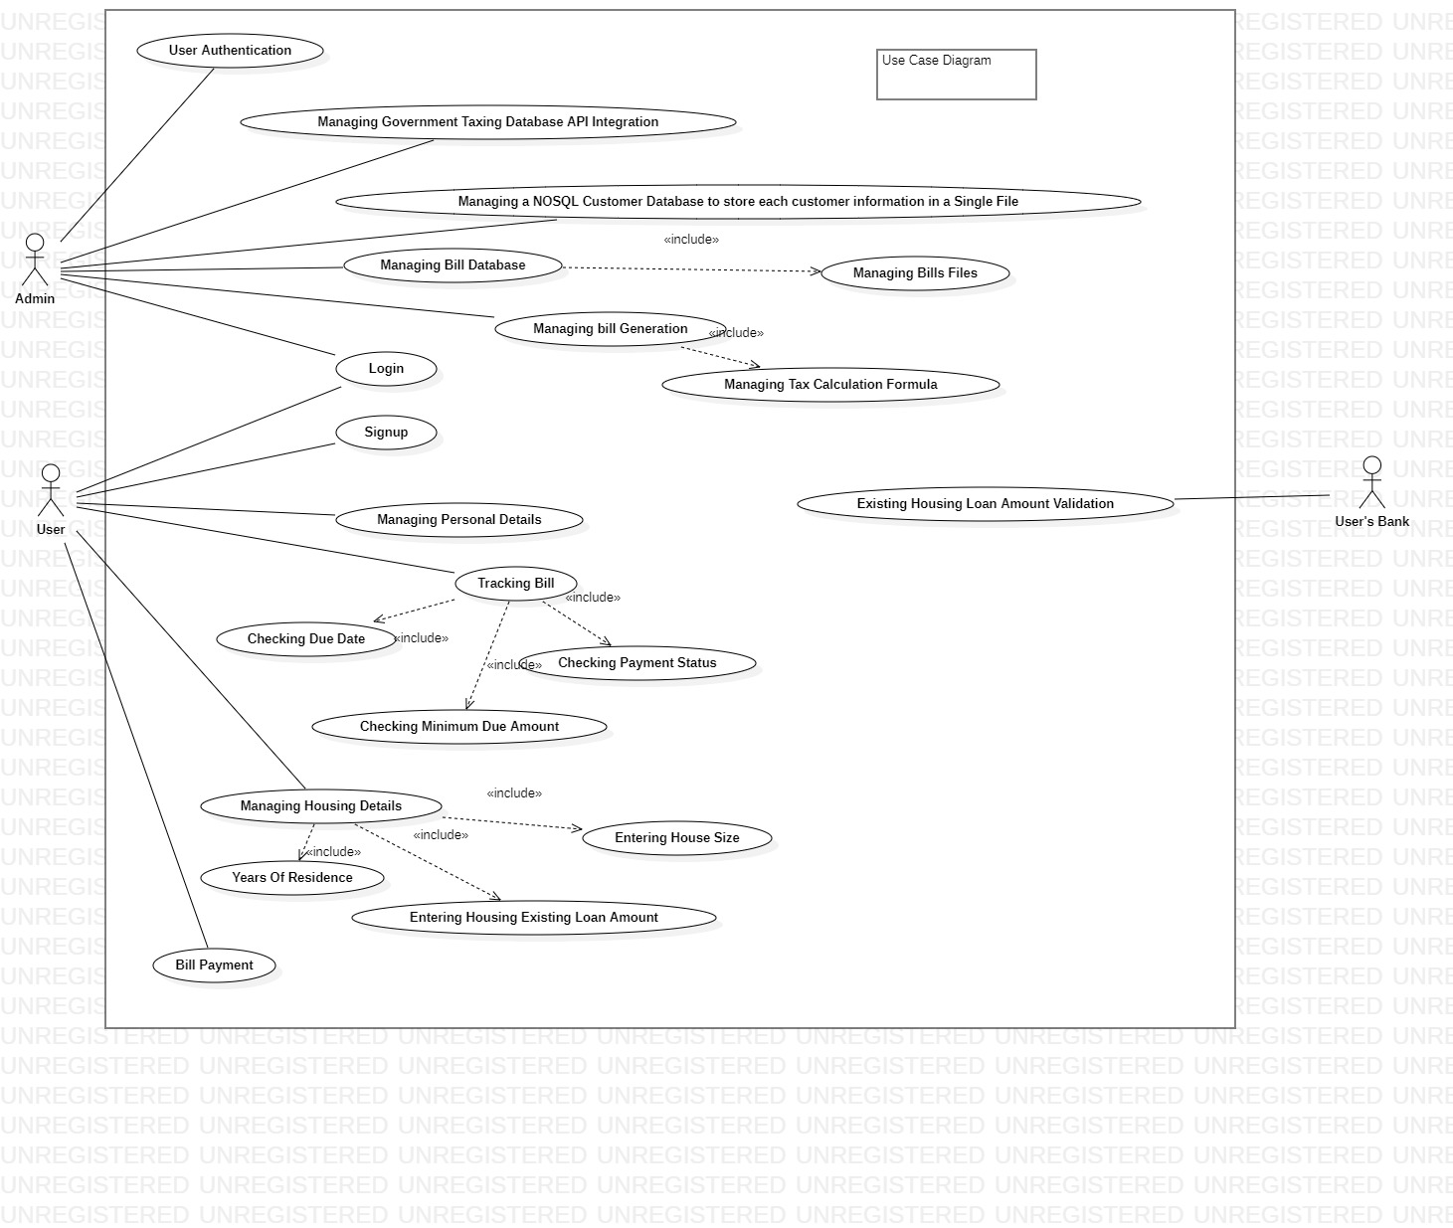

2)

Work Break Down Structure:

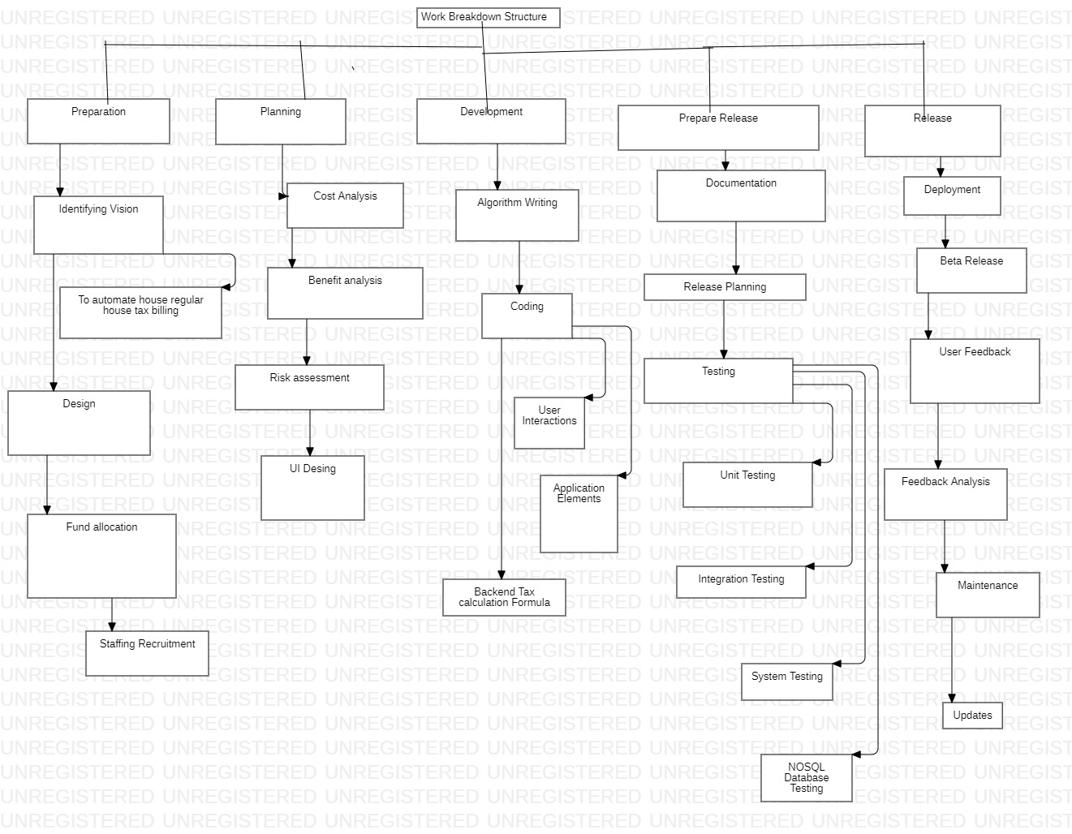

Result: Use case Diagram and Work Breakdown Structure has been successfully developed for an Online House Tax Billing System using StarUML Software.